Redmond_Ben_200412111_ Web Design & Development

CA_ONE

This project aimed to design a brochure website for a Bed & Breakfast Business in Galway City.  
  
I started with the overall design of the website using Figma, making a wireframe of the website and indicating where I wanted content and page layout.

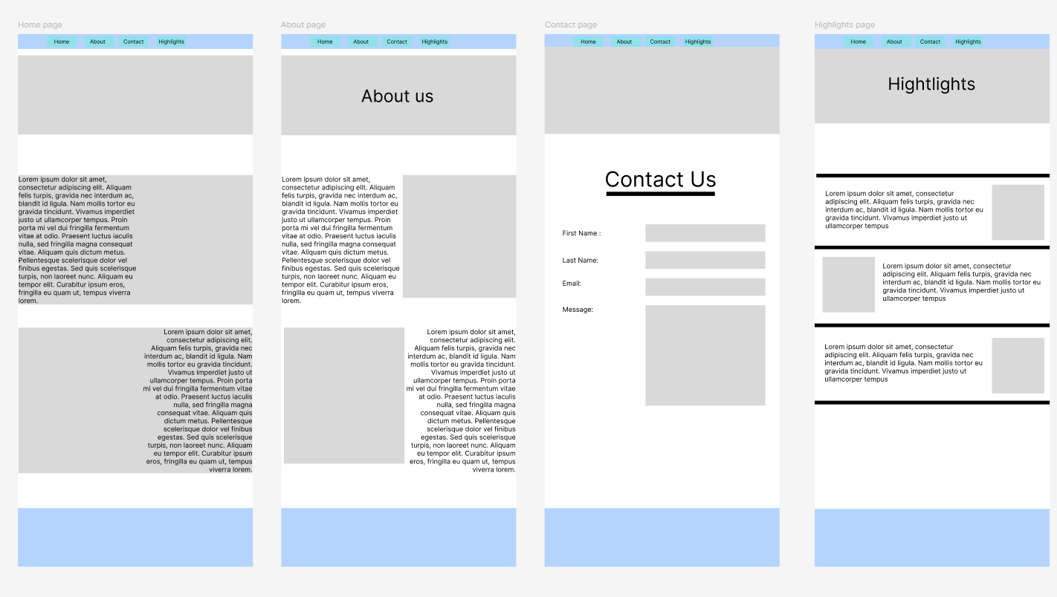

For this project, I started using GitHub Desktop. Just so I would have a quick way of updating what I was doing, and my work could be remote. Here is a link to my repo   
<https://github.com/BenRedmondgithub/20041211_Redmond_Ben_WebDev-project>

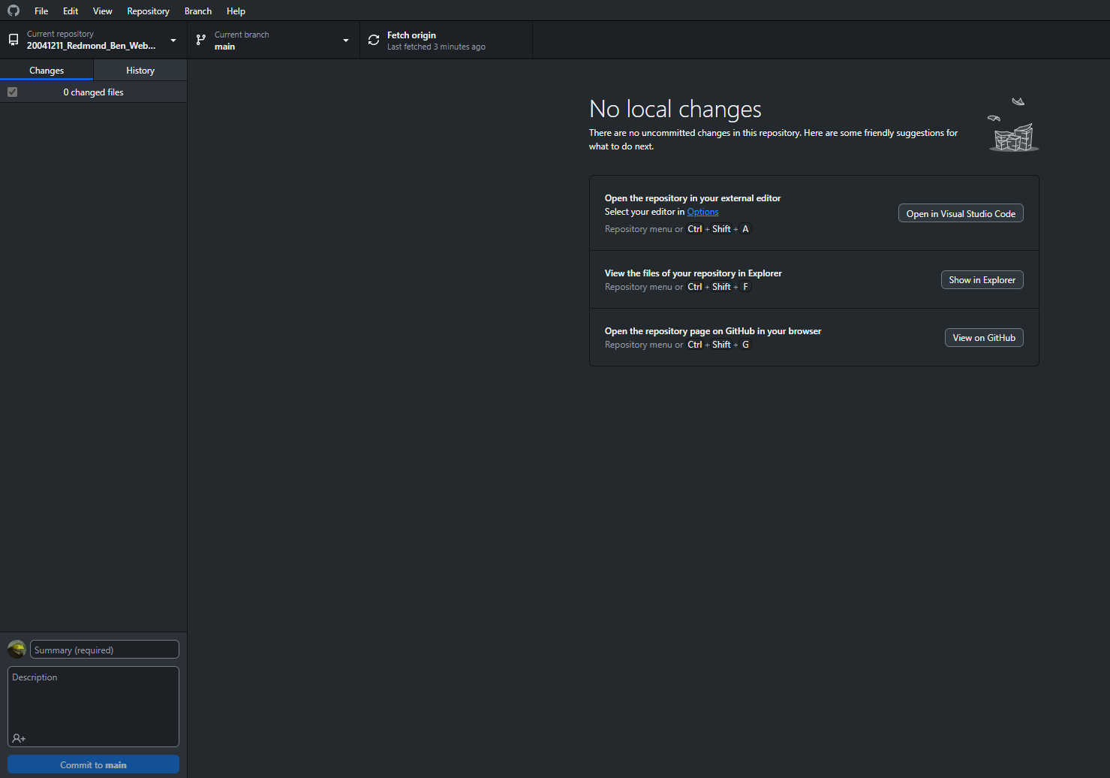

The very first thing I did was set up the Navbar with links to all the other pages the next was to create a div to hold the hero image and the H1 In place, the Navbar and the main text on screen using Merienda linked with Google fonts, here is a link to the font.

<https://fonts.google.com/specimen/Merienda?query=Merienda>

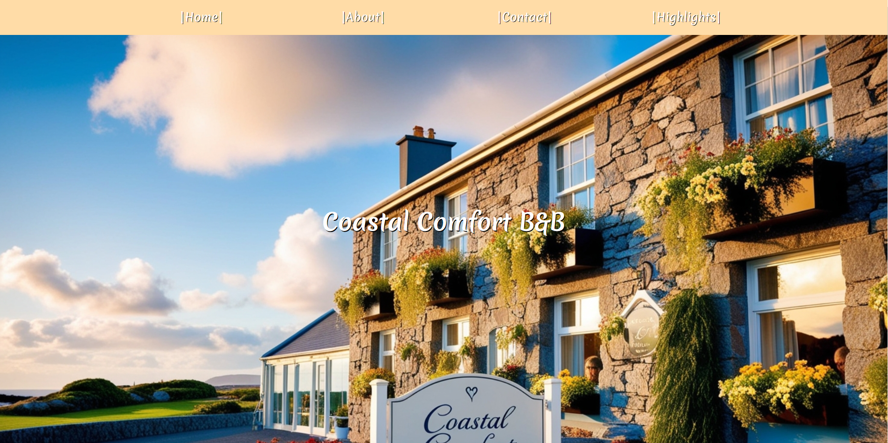

Then, I used the main tag and created two divs with text and two images, one image on the right with text on the left and the other the opposite way. It was a bit hard to understand how if you use float left and right, the images will work out.

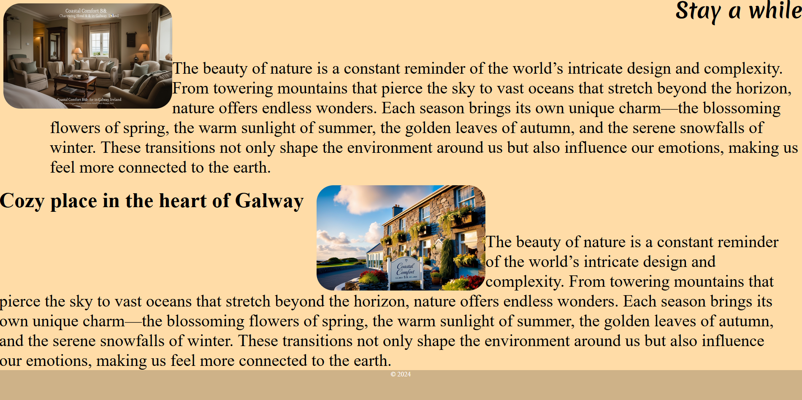

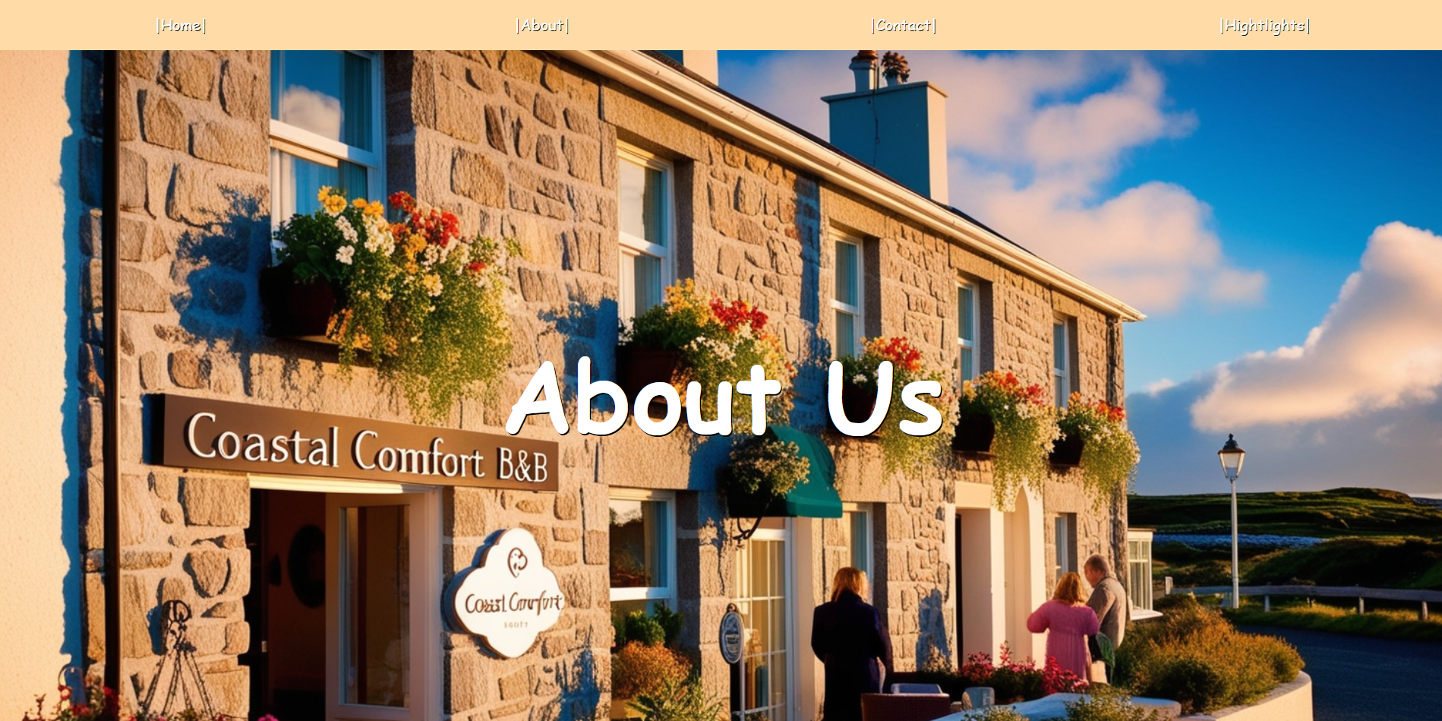

Then, I started the About page. However, this hero image is different from the main home page image. I started using background image in my CSS and put the background image within the first div. I found it quite hard to make changes to the Homepage if the Hero image was in the first div. The background image helped me very much in that regard.

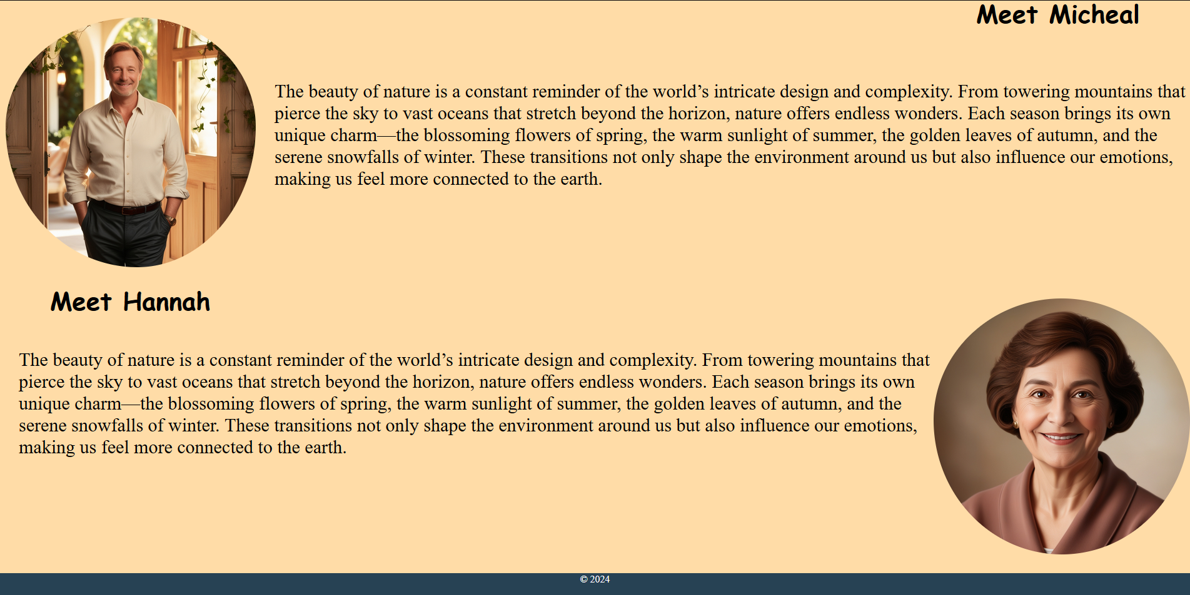

For this part of the About page, I used the same code as I used on the home page and just replaced the images and text on the page

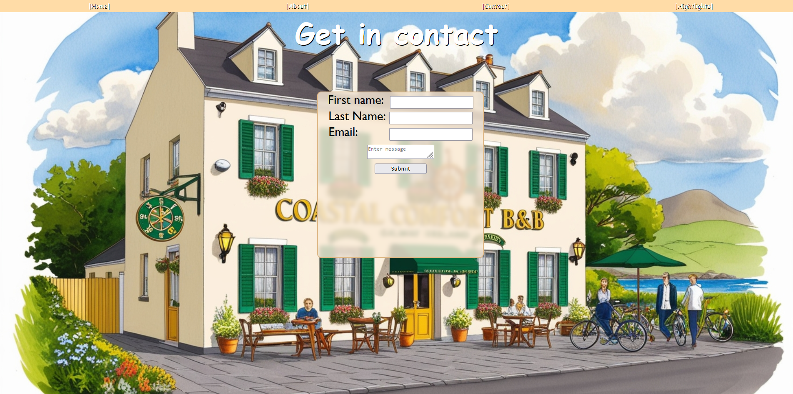

I learned from setting a background image on the last page and used the same code. The form needed input for First name, Last name, email, and a message box.

